**RESUME**

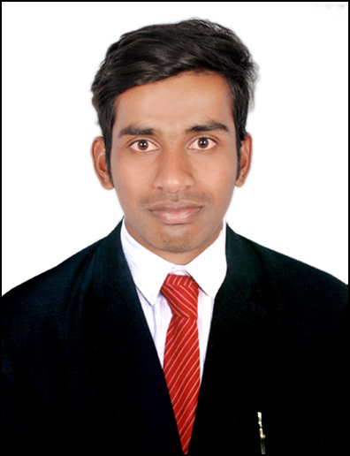

**MOHD KAREEM UDDIN**

**Email-Id: kareemit019@gmail.com**

**Mobile No: +91-904099986**

**OBJECTIVE**

**To work in a dynamic organization and utilize my skills and efforts for my personal as well as organizational success and growth by constantly attaining the niche skill set demanded by the roles in which I am working**

**EDUCATION QUALIFICATION:**

* **B.tech ( civil) from JNTUH, Hyderabad, India.**
* **Diploma (civil) from state board technical education institute, Hyderabad, India.**
* **I.T.T (DRAUGTHSMAN CIVIL) from Industrial Training Institute, Telangana, India.**
* **SSC from Board of Secondary Education, Telangana, India.**

**.**

**TECHNICAL SKILLS**

* **PACKAGES Ms-Office (Ms-Word, Ms-Excel , Ms- Power Point),**
* **DESIGNING AUTOCAD**
* **SOFTWARE Salesforce**

**PERSONAL DETAIL:**

**Name : Mohd Kareem Uddin**

**Father Name : Khatib Moin uddin**

**Nationality : Indian**

**Language : English, Hindi, Urdu, Telugu**

**Driving License : Indian (2 & 4 Wheeler)**

Address : Hyderabad - INDIA